A Cuppa and a Natter
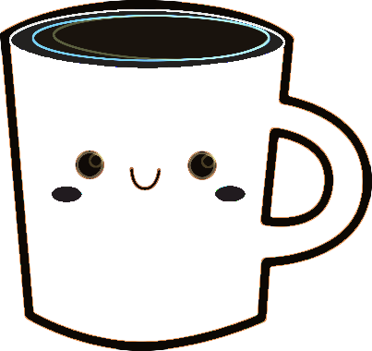
Meeting Group
for Older Adults
Come and make new friends!
Enjoy a cuppa, a biscuit, and a friendly chat in a warm, welcoming environment.


Date: Saturday, 3rd May
Time: 10 am – 12 noon
This session, hosted in partnership with Grovehurst Patient Participation Group, is primarily for older adults who may not have the opportunity to get out much.
It’s a chance to socialise, share stories, and connect with community members.
No need to book. Pop in and say hello! We’d love to see you there.
For more information, contact Nikki Howe – Practice Manager.

